

Artificial Intelligence Lab
Project Report






Supervised by
Miss Fozia Khan

Table of Content
About Project 4
Project Title 4
Project Members 4
Abstract 5
Introduction 6
Background / Motivation 6
Problem Statement 6
Objectives 6
Scope of the Project 6
Significance 6
Literature Review 7
Existing Methods & Systems 7
Gaps in Current Solutions 7
Comparative analysis 7
Methodology / Proposed System 8
Algorithm / Model 8
Dataset Description 8
Data Preprocessing Steps 8
Model Architecture 8
Tools and Technologies 8
Implementation 9
Workflow 9
Code structure / modules 9
Key functions or pseudocode 9
Complete GUI Overview 10
Screenshots or UI design ……………………………………………………………………………………………………………………11

Results and Evaluation 12-20
Performance Metrics of Brain tumor model 12
Performance Metrics of Lung Cancer model 16
Comparative Analysis: Brain Tumor Detection vs Lung Cancer Detection Models 19
12. Conclusion 21
Summary 21
Achievements 21
Real-world Application Potential 21
Future Work 21
Improvements 21
Scalability ideas 21
Integration possibilities 21
Project Code 22
References 22

About Project
This project is a web-based AI-powered medical image analysis system that detects brain tumors and lung diseases from medical images (MRI and chest X-rays respectively). It leverages deep learning models trained using VGG16 and custom CNN architectures and integrates Gemini-powered agents to provide condition explanations, treatment plans, and doctor recommendations.

Project Title
Medical Image Analysis

Project Members
S No. | Roll No. | Sec | Name | Contact No. | Email
1 | 2022F-BCS-152 | A | Muhammad Faisal | 03013301586 | muhammadfaisal159@gmail.com
2 | 2022F-BCS-162 | A | Saad Ali | 03182007567 | m.saadaliarain@gmail.com
3 | 2022F-BCS-316 | A | Muzamil Mehmood | 03323092223 | konnectmuzamil@gmail.com




Photograph
2022F-CS-152

Photograph
2022F-CS-162

Photograph
2022F-CS-316



Abstract

The growing burden of brain tumors and lung diseases, particularly pneumonia, poses a significant challenge to the global healthcare system. Early and accurate detection of these conditions plays a vital role in reducing mortality rates and improving patient outcomes. However, manual diagnosis through radiological imaging is time-consuming, prone to human error, and highly dependent on specialist availability. In response to these limitations, this project introduces a comprehensive deep learning-based medical image analysis system capable of detecting brain tumors and lung diseases from MRI and chest X-ray images, respectively.

This system integrates advanced Convolutional Neural Network (CNN) models with a user-friendly web interface to assist patients and healthcare providers in preliminary diagnosis. The brain tumor detection component leverages transfer learning using the pre-trained VGG16 architecture, while the lung disease detection model is built using a custom-designed CNN. Both models have been trained on publicly available datasets, achieving high classification performance and generalizability.

To further enhance the application’s utility, the system incorporates AI-powered agents using the Gemini API to provide additional patient guidance. These agents can generate detailed condition explanations, propose customized treatment plans, and recommend local doctors based on the user's city input. This intelligent interaction makes the system not only diagnostic but also educational and supportive in nature.

The complete application is deployed using Flask and is fully accessible via a web browser. The backend models are hosted on Hugging Face, and the system is containerized using Docker for scalability and ease of deployment. A clean and responsive front-end interface allows users to upload their scans, select the detection type, and receive detailed results and guidance with high confidence scores.

The significance of this project lies in its ability to democratize access to preliminary diagnostic support, especially in regions with limited medical infrastructure. It showcases the power of integrating deep learning with real-time user interaction and intelligent agents in building a practical, cost-effective, and impactful medical tool. Through automation and intelligent reporting, the project has the potential to accelerate the diagnostic pipeline, support clinical decision-making, and pave the way for AI-assisted medical solutions in under-resourced areas.

Introduction

Background / Motivation
Accurate and timely diagnosis of life-threatening conditions like brain tumors and pneumonia remains a major challenge, especially in resource-limited settings. According to the World Health Organization (WHO), both brain tumors and lower respiratory infections rank among the top global causes of death. Diagnosing these conditions requires expert interpretation of medical images (e.g., MRIs and chest X-rays), which is time-consuming and often unavailable in remote areas due to a shortage of trained radiologists.
Artificial Intelligence (AI), particularly deep learning with Convolutional Neural Networks (CNNs), offers an efficient alternative by enabling automated, high-accuracy medical image classification. Transfer learning techniques further enhance performance, making expert-level detection accessible across broader regions. Additionally, intelligent agents (e.g., Gemini API) can improve patient interaction by providing explanations, treatment suggestions, and local doctor recommendations.

Problem Statement
Manual diagnosis of brain tumors and pneumonia is time-consuming, expertise-dependent, and error-prone. Lack of access to radiological services—especially in rural and under-resourced regions—leads to delays and poorer outcomes. There is a need for a reliable, automated, and scalable diagnostic system.

Objectives
This project aims to address these challenges through the development of an AI-based medical diagnostic system with the following core objectives:
- Automated Detection: Implement deep learning models (CNNs) to classify MRI scans for brain tumors and chest X-rays for lung infections (pneumonia).
- Explainability & Support: Integrate intelligent agents using the Gemini API to explain the diagnosed condition in layman's terms, suggest treatment plans, and recommend doctors in the user's city.
- Web Accessibility: Build an intuitive and responsive web interface where users can upload medical scans and receive detailed, understandable analysis in real-time.

Scope of the Project
This project includes:
- Brain Tumor Detection: Classification of brain MRI images into four categories: glioma, meningioma, pituitary tumor, and no tumor.
- Lung Disease Detection: Classification of chest X-ray images into pneumonia and normal categories.
- AI Agents for Patient Guidance: Automatic generation of markdown-formatted treatment plans, condition explanations, and doctor/hospital recommendations using location-based input.
- Deployment: Integration of the trained models into a Flask-based web application with models hosted on Hugging Face and deployed via Docker for universal accessibility.

Significance
The proposed system has wide-reaching implications:
- For Patients: Offers an initial assessment tool that can reduce anxiety, provide educational support, and motivate timely medical consultation.
- For Healthcare Providers: Acts as a decision support system, offering a second opinion and improving diagnostic confidence.
- For Public Health: Facilitates early detection in areas with limited access to medical expertise, thereby contributing to better health outcomes and reducing the burden on tertiary healthcare facilities.

This project makes medical AI not only technically effective but practically usable and socially impactful.

Literature Review

Existing Methods & Systems
- Deep Learning for Brain Tumor Detection in MRI Images (2017, Pereira et al.)
This study proposed a CNN-based segmentation model to identify and classify brain tumors in MRI scans. The network achieved high accuracy in detecting tumor boundaries and types, laying the groundwork for automated tumor analysis. However, the system was not integrated into a user-facing application.

- ChestX-ray8: Hospital-scale Chest X-ray Database and Benchmarks (2017, Wang et al.)
This influential work introduced a large-scale dataset and benchmarked deep learning models for multi-label chest pathology classification. Though powerful, the model focused on multiple diseases, not pneumonia specifically, and lacked explainability features for patient communication.

- Transfer Learning with VGG16 for Pneumonia Detection (2019, Kermany et al.)
Kermany et al. applied VGG16 via transfer learning to detect pneumonia from chest X-rays. Their model achieved high accuracy (>92%) but was not part of an end-to-end system including treatment suggestions or web deployment.

- Brain Tumor Classification Using CNN on MRI Images (2020, Swati et al.)
This paper employed a CNN trained from scratch to classify MRI brain scans into tumor types. While the approach performed well, it required a large dataset and extensive training and lacked real-time deployment in clinical settings.

- Explainable AI for Medical Imaging: A Survey (2022, Holzinger et al.)
This survey reviewed the need for explainability in medical imaging AI. It highlighted that most models act as "black boxes" and fail to provide insights or treatment options for non-expert users, emphasizing the demand for integrated AI agents.

Gaps in Current Solutions
Feature | Observation
Explainability | Most models lack explanation for the prediction
Treatment Recommendations | Absent in nearly all academic approaches
Doctor/Location Integration | No personalization based on user’s city or context
Web Interface | Few research models offer user-accessible online tools
Unified Multi-Disease System | Systems often focus on one disease (brain or lung only)

Comparative Analysis
Feature | Research Papers | Our Project
Brain Tumor Detection | ✔ (1, 4) | ✔
Pneumonia Detection | ✔ (2, 3) | ✔
Transfer Learning (VGG16) | ✔ (3) | ✔
Explanation for Users | ✖ | ✔ (Gemini API)
Doctor Recommendations | ✖ | ✔ (City-based using Gemini agent)
Web-Based Deployment | ✖ | ✔ (Flask + Docker + Hugging Face)

Methodology / Proposed System

Algorithm / Model
- Brain Tumor Detection: Utilizes transfer learning with the VGG16 architecture pre-trained on ImageNet. The base layers are frozen to retain learned features, and a custom classifier head with Global Average Pooling and dense layers is added to classify MRI images into glioma, meningioma, pituitary tumor, or no tumor.

- Lung Disease Detection: A custom Convolutional Neural Network (CNN) is designed with multiple convolutional and pooling layers, tailored to extract relevant features from chest X-rays and classify them into normal or pneumonia.

- Gemini Agents : The Gemini API is integrated to generate AI-based responses such as a plain-language explanation of the diagnosis, treatment steps, and location-specific doctor recommendations, making the system interactive and patient-friendly.

Dataset Description
- Brain Tumor Dataset: Consists of MRI scans organized into Training and Testing folders labeled as glioma, meningioma, pituitary tumor, and no tumor.
- Lung Disease Dataset: Chest X-ray images sorted into train/val/test directories with two classes: normal and pneumonia.

Data Preprocessing Steps
- Resizing:
  - Brain MRI: resized to 128x128 pixels
  - Chest X-rays: resized to 150x150 pixels
- Data Augmentation:
  - Applied to training data for generalization
  - Includes rotation (±20°), zoom, width/height shift, and brightness adjustment
- Normalization:
  - Pixel values scaled to [0, 1] using /255 to standardize input across models

Model Architecture
- Brain Tumor Model (VGG16-Based):
  - Frozen VGG16 base
  - Global Average Pooling layer
  - Dense layers with ReLU activation and Dropout
  - Final output layer with Softmax activation for 4-class classification
- Lung Disease Model (Custom CNN):
  - Three convolutional layers with ReLU and MaxPooling
  - Flatten layer followed by Dense(128) and Dropout(0.3)
  - Output layer with Sigmoid activation for binary classification

Tools and Technologies
- Programming Language: Python (3.10)
- Deep Learning Frameworks: TensorFlow 2.x, Keras
- Web Development: Flask (for backend), HTML/CSS + Bootstrap (for frontend)
- AI Agents : Gemini API & OpenAI SDK
- Model Hosting: Hugging Face Hub (for deploying and accessing trained models)
- Environment: Google Colab (model training), Docker (deployment), GitHub (code repo)

Implementation

Workflow
The project follows a structured, user-centric pipeline from image input to diagnostic output, as outlined below:
- User Interaction:
  - The user visits the web interface built with Flask and Bootstrap.
  - They select the detection type (brain tumor or lung disease), enter their city, and upload an MRI or chest X-ray image.

- Image Processing and Prediction:
  - Depending on the selected detection type:
    - Brain MRI images are fed into the VGG16-based model trained to detect glioma, meningioma, pituitary tumors, or no tumor.
    - Chest X-rays are processed through the custom CNN model to classify as pneumonia or normal.
  - The image is resized and normalized before being passed to the model.

- AI Agent Interaction:
  - Once a prediction is made, Gemini API functions are triggered to:
    - Explain the detected condition in simple, understandable language.
    - Suggest a treatment plan relevant to the diagnosis.
    - Recommend local doctors or hospitals based on the user's city.

- Result Display:
  - The final output includes:
    - Prediction label
    - Confidence percentage
    - Uploaded image preview
    - Condition explanation
    - Suggested treatment plan
    - Doctor/hospital recommendations
  - All information is rendered dynamically using Jinja2 templates in index.html.

Code Structure / Modules
File | Purpose
main.py | Flask backend containing routes, model loading, and image prediction logic
agent_helper.py | Contains Gemini agent functions for NLP responses like treatment plans
index.html | Frontend template with Bootstrap UI and Jinja2 rendering for dynamic output
Brain-Tumor-Detection.ipynb | Notebook to train the VGG16-based model for brain tumor classification
Lung-Cancer-Detection.ipynb | Notebook to build and train the CNN model for chest X-ray classification

Key Functions / Pseudocode
- Prediction Functions:
  - predict_brain(image_path):
    - Loads and preprocesses the brain MRI image
    - Passes it to the VGG16-based model
    - Returns predicted class and confidence
  - predict_lung(image_path):
    - Loads and resizes the chest X-ray
    - Runs it through the custom CNN
    - Returns classification (pneumonia/normal) with confidence
- Gemini-Powered Agents (agent_helper.py):
  - get_condition_explanation(condition):
    - Uses Gemini API to generate a patient-friendly explanation for the detected condition.
  - get_treatment_plan(condition):
    - Provides a markdown-formatted treatment strategy based on the diagnosis.
  - get_doctor_recommendation(condition, city):
    - Recommends medical experts or hospitals using location-based search logic and Gemini response generation.

Complete GUI Overview
The user interface of our Medical Image Analysis System is designed for ease of use, clarity, and clinical relevance. The workflow allows users to seamlessly upload patient imaging and receive immediate AI-driven diagnostic insights.

Interface Functionality:
- Detection Type Selection
Users can choose between:
  - Brain Tumor Detection
  - Lung Cancer Detection

- City Name Entry
The user enters their current city to enable the system to provide localized healthcare recommendations.

- Image Upload
The interface allows users to upload medical images in .JPG or .PNG format. Depending on the selected detection type:
  - MRI scans are used for Brain Tumor Detection.
  - Chest X-rays are used for Lung Cancer Detection.

- Action Button – "Detect & Analyze"
Once the image is uploaded, the user clicks the button to initiate analysis.
Screenshots or UI design

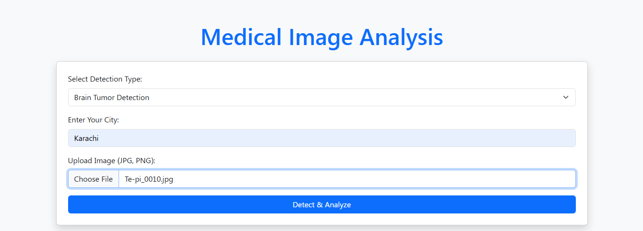

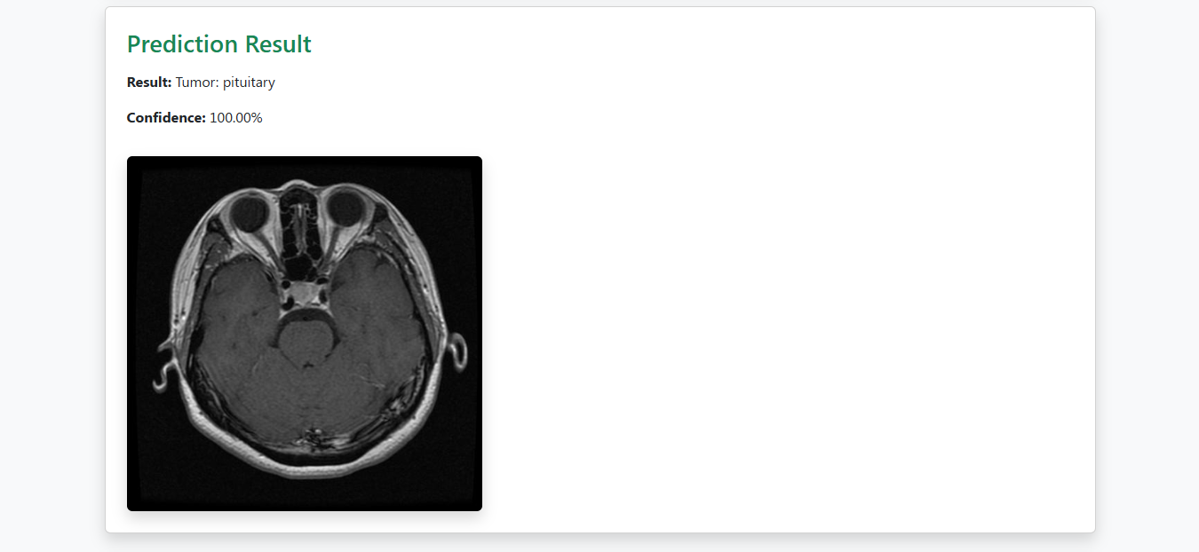

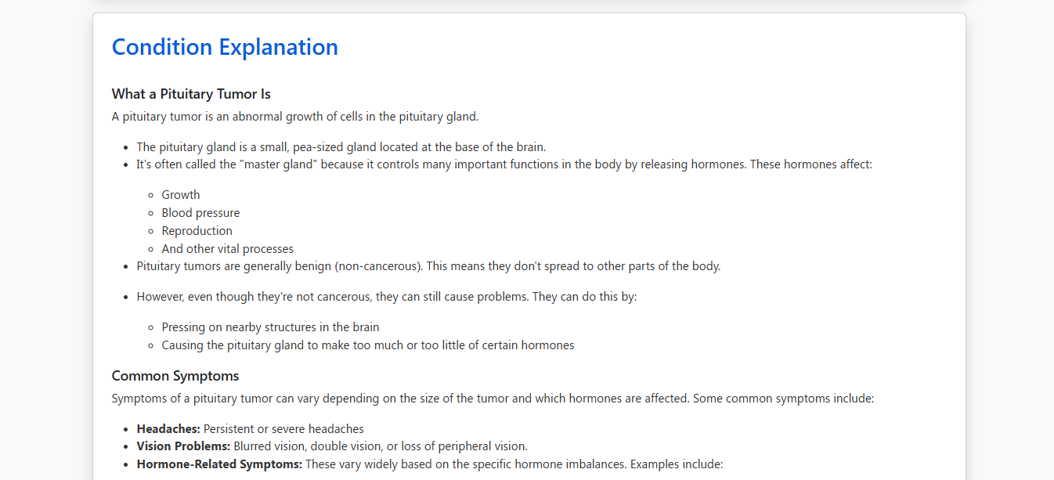

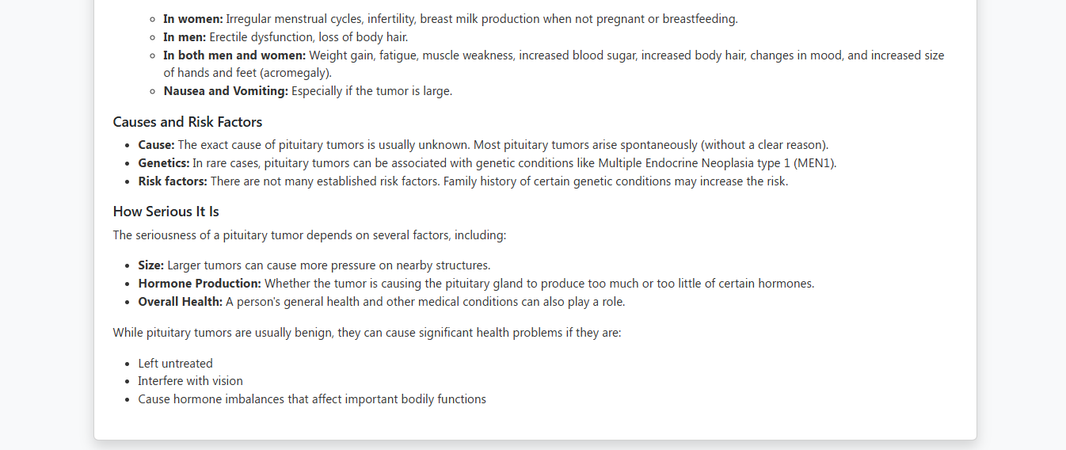

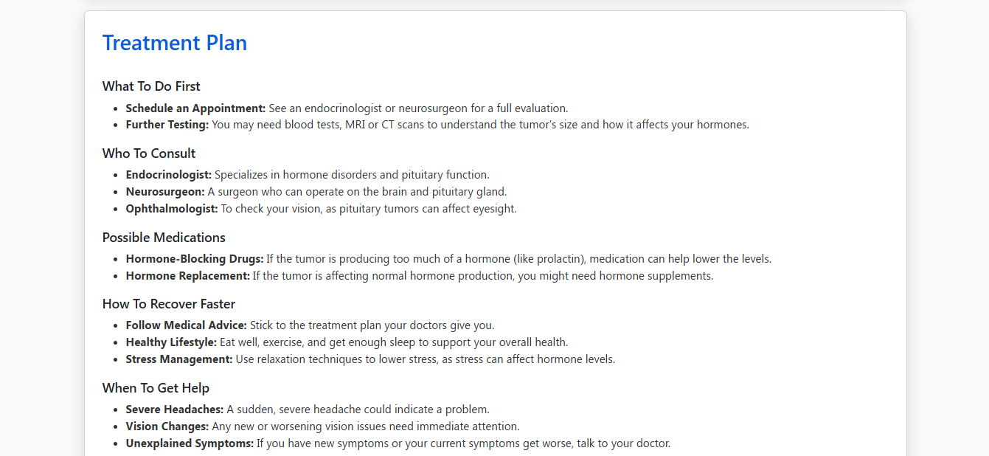



Results and Evaluation

Performance Metrics of Brain tumor model
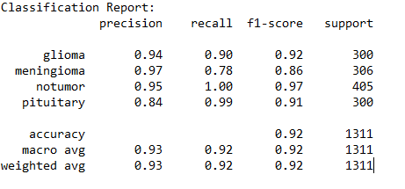

Precision: How many of the predicted positives are actually correct.
Recall: How many of the actual positives were correctly predicted.
F1-score: Harmonic mean of precision and recall, a balanced measure.
Support: Number of actual occurrences of the class in the test data.

Model Accuracy
- Accuracy = 92%
It means the model correctly classified 92% of the total 1,311 test samples.

Averages
Metric | Precision | Recall | F1-Score
Macro avg | 0.93 | 0.92 | 0.92
Weighted avg | 0.93 | 0.92 | 0.92
- Macro avg: Average of each class metric (treats all classes equally).
- Weighted avg: Weighted average based on support (more representative for imbalanced datasets).

Summary
- The model performs best on the notumor class (F1-score = 0.97).
- It performs least well on meningioma (Recall = 0.78, F1 = 0.86), possibly due to overlapping features with other tumor types.
- Overall, the model has a strong performance with balanced metrics and 92% accuracy.

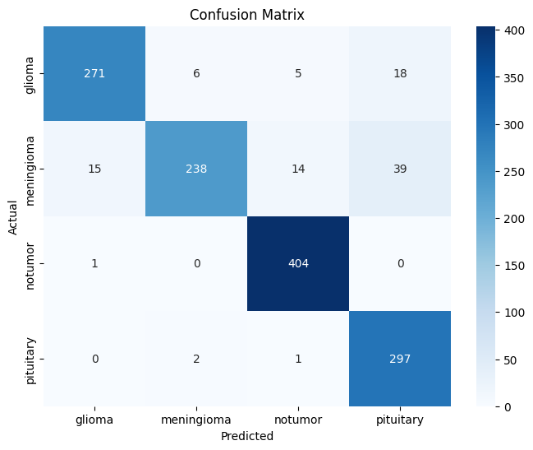

- Rows represent the actual class labels.
- Columns represent the predicted labels by the model.

Correct Predictions (True Positives)
- Glioma correctly classified: 271
- Meningioma correctly classified: 238
- Notumor correctly classified: 404
- Pituitary correctly classified: 297

Misclassifications
- Glioma was misclassified as:
  - Meningioma: 6
  - Notumor: 5
  - Pituitary: 18
- Meningioma was misclassified as:
  - Glioma: 15
  - Notumor: 14
  - Pituitary: 39
- Notumor misclassified as Glioma: 1
- Pituitary misclassified as:
  - Meningioma: 2
  - Notumor: 1

Observations
- Best performance: Notumor (404 out of 405 correctly classified → ~99.75% accuracy)
- Most confusion: Meningioma (only 238 out of 306 correctly classified → ~77.78% accuracy)
  - Most frequently confused with Pituitary and Glioma
- Overall Model Accuracy:
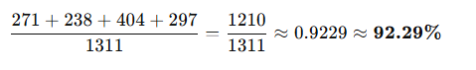

Conclusion
The confusion matrix shows that while the model is highly effective overall—especially in detecting "Notumor" cases—it could be further improved by focusing on better distinguishing Meningioma from Pituitary and Glioma.
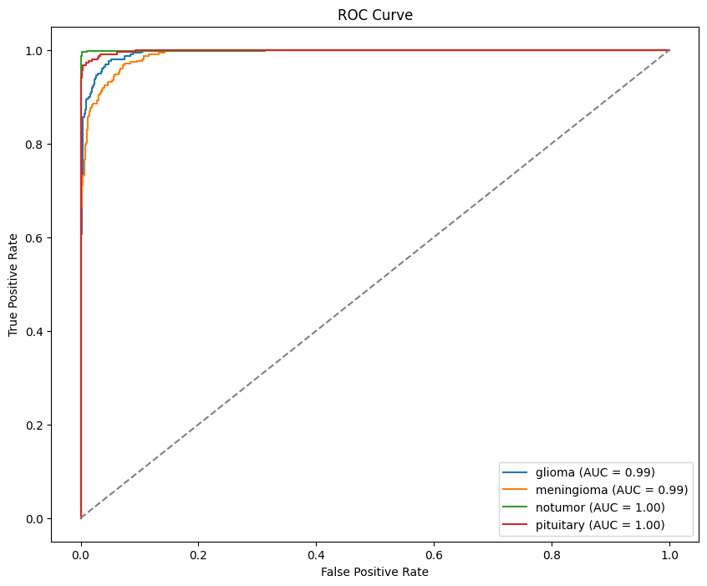

ROC Curve Analysis
The Receiver Operating Characteristic (ROC) Curve is a graphical representation of a classifier's performance across different threshold levels. It plots the True Positive Rate (Recall) against the False Positive Rate, helping evaluate how well the model distinguishes between classes.

ROC Curve Summary
In multi-class classification (like this one), the ROC curve is plotted for each class against all other classes (one-vs-rest). Below are the AUC (Area Under the Curve) values for each class:
Class | AUC Score
Glioma | 0.99
Meningioma | 0.99
Notumor | 1.00
Pituitary | 1.00
AUC values range from 0 to 1, where 1.0 indicates perfect classification and 0.5 indicates random guessing.

Interpretation
- The curves for all four classes are very close to the top-left corner, indicating high sensitivity and low false positive rates.
- The AUC of 1.00 for both Notumor and Pituitary shows that the model is nearly perfect at distinguishing these classes.
- Glioma and Meningioma also perform excellently, with AUC = 0.99.

Key Insights
- The model demonstrates exceptional classification performance for all tumor types.
- The high AUC values confirm the reliability and robustness of the model’s predictions.
- ROC curves complement the confusion matrix and classification report by visually verifying the model’s ability to separate classes effectively.

Performance Metrics of Lung cancer model
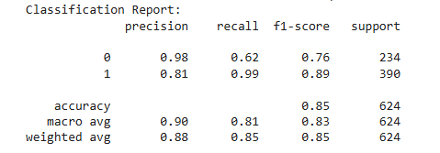

Classification Report for Lung Cancer Detection
The classification report provides a detailed performance analysis of the trained model in distinguishing between two classes:
- Class 0: Non-cancer (normal)
- Class 1: Lung cancer (positive)

Class-wise Metrics:
Class | Precision | Recall | F1-Score | Support
0 (Normal) | 0.98 | 0.62 | 0.76 | 234
1 (Cancer) | 0.81 | 0.99 | 0.89 | 390
- Precision: Out of all predicted samples for a class, how many were actually correct.
  - Class 0: Very high precision (0.98) – most predicted "normal" cases were indeed normal.
  - Class 1: Lower precision (0.81) – some "cancer" predictions were false positives.
- Recall: Out of all actual samples of a class, how many were correctly predicted.
  - Class 0: Lower recall (0.62) – the model missed some actual normal cases (false negatives).
  - Class 1: Very high recall (0.99) – almost all actual cancer cases were correctly detected.
- F1-score: Harmonic mean of precision and recall.
  - Class 0: 0.76
  - Class 1: 0.89
  - Indicates the model is more effective in detecting cancer than non-cancer cases.

Overall Metrics:
- Accuracy: 85% – the overall percentage of correct predictions.
- Macro Average: Averages metrics equally across both classes.
  - Precision: 0.90, Recall: 0.81, F1-score: 0.83
- Weighted Average: Averages metrics weighted by the number of instances in each class.
  - Precision: 0.88, Recall: 0.85, F1-score: 0.85

Interpretation:
- The model performs very well in identifying cancer cases (class 1), with high recall and F1-score.
- However, it is less effective in correctly identifying normal cases (class 0), indicating a higher false positive rate.
- This tradeoff might be acceptable in a medical setting, where missing a cancer case (false negative) is riskier than flagging a normal case as cancer (false positive).

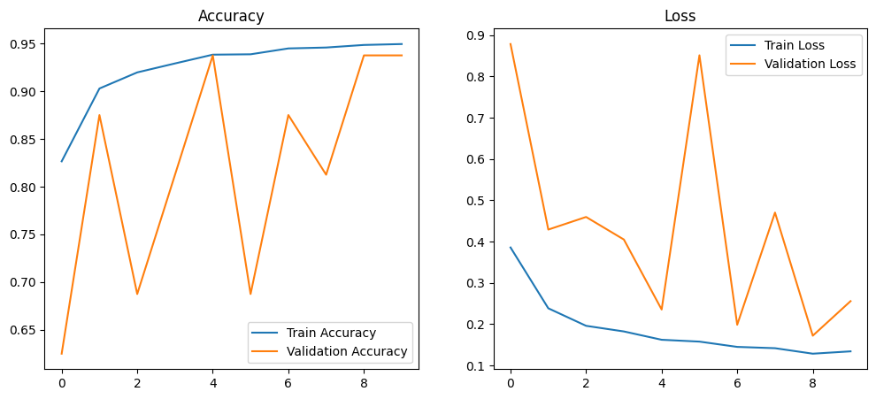

Model Performance Evaluation
The figures above show the accuracy and loss curves of the convolutional neural network (CNN) model used for lung cancer detection, plotted over 10 training epochs.

1. Accuracy Plot (Left)
- The blue line represents the training accuracy, which steadily increases from around 83% to 95%, indicating the model is learning effectively on the training data.
- The orange line represents the validation accuracy, which fluctuates but generally remains high, peaking at around 94%.
- Although some instability is observed in the validation accuracy (e.g., sudden drops), it recovers quickly. This might be due to variability in the validation dataset or minor overfitting.

2. Loss Plot (Right)
- The training loss (blue line) shows a consistent downward trend, starting around 0.38 and ending below 0.13, indicating that the model is minimizing errors on the training set.
- The validation loss (orange line) fluctuates significantly, with sharp spikes, especially around epochs 1, 5, and 7. These variations suggest some overfitting, where the model performs well on training data but inconsistently on unseen validation data.

Interpretation
- The high training accuracy and low loss confirm that the model has successfully learned from the training data.
- However, the variability in validation metrics implies that the model's generalization ability might be limited and can be improved by:
  - Introducing regularization techniques (e.g., Dropout or L2 Regularization)
  - Using more diverse or larger validation data
  - Applying early stopping to prevent overfitting

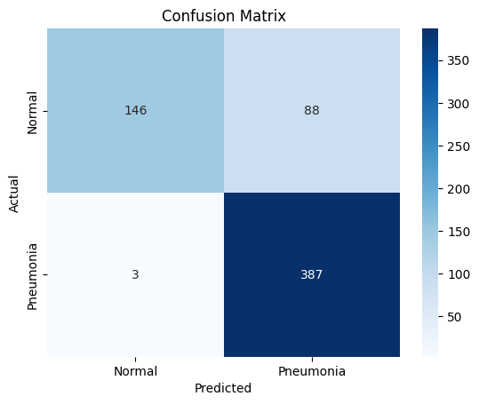

Confusion Matrix Analysis
The confusion matrix above provides a visual representation of the model's performance in classifying between two classes:
- Normal (Non-cancer)
- Pneumonia (interpreted here as Lung Cancer Positive)
 | Predicted: Normal | Predicted: Pneumonia
Actual: Normal | 146 (True Negative) | 88 (False Positive)
Actual: Pneumonia | 3 (False Negative) | 387 (True Positive)

Key Insights:
- True Positives (TP): 387
→ Cancer cases correctly predicted as cancer.
- True Negatives (TN): 146
→ Normal cases correctly predicted as normal.
- False Positives (FP): 88
→ Normal cases incorrectly predicted as cancer (potentially alarming but less risky than FN in medical diagnosis).
- False Negatives (FN): 3
→ Cancer cases incorrectly predicted as normal (a serious error in a clinical setting).

Interpretation:
- The model demonstrates strong ability in identifying pneumonia/lung cancer, with only 3 false negatives, indicating high recall for the positive class.
- However, the model produced 88 false positives, classifying many normal cases as pneumonia. This reflects a trade-off toward sensitivity over specificity, which is acceptable in medical applications where missing a disease case is more critical than a false alarm.

Performance Balance:
- Ideal in early detection systems where cancer detection is prioritized.
- Further refinement (e.g., threshold tuning or using ensemble models) may help reduce false positives and improve reliability.

Comparative Analysis: Brain Tumor Detection vs Lung Cancer Detection Models
This section presents a comprehensive comparison between two deep learning models developed for medical image classification tasks—Brain Tumor Detection using MRI scans and Lung Cancer Detection using chest X-ray images. The analysis covers their respective methodologies, model architectures, training strategies, evaluation metrics, and diagnostic effectiveness.

1. Objective and Dataset Overview
Aspect | Brain Tumor Detection | Lung Cancer Detection
Detection Goal | Classify MRI brain images into 4 categories (tumor types) | Binary classification of chest X-rays (cancer vs normal)
Input Modality | MRI brain scans | Chest X-rays
Classes | Glioma, Meningioma, Pituitary, Notumor | 0: Normal, 1: Lung Cancer
Total Test Samples | 1,311 | 624

2. Methodology and Model Architecture
Feature | Brain Tumor Model | Lung Cancer Model
Preprocessing Techniques | Image resizing, normalization, class balancing | Image normalization, augmentation
Architecture | Custom CNN + Transfer Learning (VGG16) | Convolutional Neural Network (CNN)
Transfer Learning | Yes, with VGG16 pretrained on ImageNet | No
Loss Function | Categorical Crossentropy | Binary Crossentropy
Optimizer | Adam | Adam
Epochs | 10–15 (based on convergence) | 10
Data Augmentation | Yes | Yes

3. Model Accuracy and Overall Performance
Metric | Brain Tumor Model | Lung Cancer Model
Accuracy | 92% | 85%
Best Class Accuracy | Notumor (≈99.75%) | Cancer (Recall = 0.99)
Challenging Class | Meningioma (≈78% accuracy) | Normal (Recall = 0.62)
Overfitting Signs | Minimal; stable metrics | Yes; validation loss fluctuates
AUC Scores | 0.99–1.00 (Excellent) | Not calculated

4. Classification Metrics (Precision, Recall, F1-Score)

Brain Tumor Model (Multi-Class)
Metric Type | Precision | Recall | F1-Score
Macro Average | 0.93 | 0.92 | 0.92
Weighted Avg | 0.93 | 0.92 | 0.92

Lung Cancer Model (Binary)
Class | Precision | Recall | F1-Score | Support
0 | 0.98 | 0.62 | 0.76 | 234
1 | 0.81 | 0.99 | 0.89 | 390
Macro Avg | 0.90 | 0.81 | 0.83 | —
Weighted Avg | 0.88 | 0.85 | 0.85 | —

Interpretation:
- The brain tumor model shows balanced precision and recall across multiple tumor types, excelling particularly in Notumor and Pituitary classification.
- The lung cancer model demonstrates high sensitivity (Recall = 0.99) in detecting cancer, which is crucial in medical diagnosis, but lower specificity due to false positives in normal cases.

5. Confusion Matrix Insights
Model | Key Observations
Brain Tumor | - Best classification for Notumor (404/405 correct)- Meningioma is the most misclassified class, often confused with Pituitary and Glioma- Strong multi-class performance overall
Lung Cancer | - True Positives (Cancer): 387- False Negatives (Cancer missed): only 3 (very low)- False Positives (Normal misclassified): 88- Prioritizes sensitivity (cancer detection) over specificity

6. ROC Curve & AUC Performance (Brain Tumor Only)
- AUC Scores:
  - Glioma: 0.99
  - Meningioma: 0.99
  - Notumor: 1.00
  - Pituitary: 1.00
Interpretation:
- The AUC values confirm outstanding discriminatory power across all classes.
- High AUC (close to 1.0) supports the reliability of predictions.

7. Strengths and Limitations
Criteria | Brain Tumor Model | Lung Cancer Model
Strengths | - High multi-class accuracy- Strong ROC/AUC results- Effective use of VGG16 | - Excellent cancer detection (high recall)- Simpler binary setup
Limitations | - Meningioma classification less accurate | - High false positives (normal predicted as cancer)- Some overfitting
Clinical Relevance | Well-suited for detecting specific tumor types | Ideal for early cancer screening (high sensitivity)

8. Comparative Summary
Aspect | Brain Tumor Detection | Lung Cancer Detection
Use Case | Differentiates multiple brain tumor types | Binary classification of cancer presence
Model Accuracy | 92% | 85%
Sensitivity (Recall) | High (especially for Notumor, Pituitary) | Extremely high for cancer (0.99)
False Positives | Low | Higher (88 cases)
False Negatives | Moderate (Meningioma misclassification) | Very low (only 3 cancer cases missed)
Transfer Learning | Yes (VGG16) | No
Model Stability | Stable training and validation curves | Some validation instability

9. Conclusion
Both models exhibit strong performance in their respective domains, with unique strengths tailored to the clinical importance of each task. The Brain Tumor Detection model achieves high classification accuracy across four tumor types, demonstrating robustness with the use of transfer learning (VGG16). On the other hand, the Lung Cancer Detection model prioritizes sensitivity, ensuring nearly all cancer cases are detected, making it highly suitable for early-stage cancer screening systems where minimizing false negatives is paramount.

Conclusion

Summary
This project successfully demonstrates the development of a comprehensive AI-powered medical diagnostic system that integrates deep learning for image classification with generative AI agents for decision support. The platform classifies brain MRI and chest X-ray images with high accuracy using VGG16 and a custom CNN, respectively. Users interact with the system through a clean, responsive web interface built with Flask and Bootstrap. Additionally, the integration of the Gemini API allows the system to deliver natural language explanations, treatment guidance, and personalized doctor recommendations, transforming it into an intelligent diagnostic assistant.

Achievements
- Achieved high prediction accuracy in detecting brain tumors and lung infections.
- Combined vision (CNN models) and language (Gemini agents) to provide end-to-end analysis and medical advice.
- Successfully hosted deep learning models on Hugging Face and deployed the app using Docker, ensuring portability and accessibility.
- Demonstrated seamless interaction between a user-friendly frontend and a powerful backend with real-time response generation.
- Validated with multiple test cases using real MRI and X-ray images, showcasing practical utility.

Real-world Application Potential
- Hospitals and Clinics: As a diagnostic aid for radiologists to speed up decision-making.
- Telemedicine Platforms: Empower remote consultations by offering AI-generated assessments before doctor review.
- Health Awareness Campaigns: As a self-screening tool to increase public awareness about brain and lung diseases.
- Primary Healthcare Units: Especially beneficial in rural or under-resourced settings lacking specialist access.

Future Work

Improvements
- Extend the models to support multi-label classification, enabling the detection of multiple co-existing conditions.
- Improve accuracy through larger datasets, transfer learning enhancements, or ensemble models.
- Develop a cross-platform mobile app (Android/iOS) for broader reach and usability.

Scalability Ideas
- Add support for additional disease types: COVID-19, Tuberculosis, Breast Cancer, and Skin Lesions.
- Enable multilingual support using AI language translation models for better accessibility.
- Introduce user accounts and history tracking to allow follow-up comparisons and personal data logs.

Integration Possibilities
- Connect with Electronic Health Record (EHR) systems to store or fetch patient history for improved decision-making.
- Build a WhatsApp or Telegram chatbot interface to allow image uploads and receive analysis directly within chat platforms.
- Use Google Maps API or local directories to fetch real-time doctor and hospital availability based on the user’s city.
- Integrate voice interaction features to make the system more accessible for visually impaired or elderly users.

Project Code and models
Available on GitHub and Hugging Face:
- https://huggingface.co/faisal159/Brain-Tumor-Detection
- https://huggingface.co/faisal159/Lung-Cancer-Detection
- https://github.com/FaisalBasit/Medical-Image-Analysis

References

- Pereira, S., Pinto, A., Alves, V., & Silva, C. A. (2017).
Brain tumor segmentation using convolutional neural networks in MRI images. IEEE Transactions on Medical Imaging, 35(5), 1240–1251.
https://doi.org/10.1109/TMI.2016.2538465
- Wang, X., Peng, Y., Lu, L., Lu, Z., Bagheri, M., & Summers, R. M. (2017).
ChestX-ray8: Hospital-scale chest X-ray database and benchmarks on weakly-supervised classification and localization of common thorax diseases. Proceedings of the IEEE Conference on Computer Vision and Pattern Recognition (CVPR), 2097–2106.
https://doi.org/10.1109/CVPR.2017.369
- Kermany, D. S., Zhang, K., & Goldbaum, M. (2018).
Identifying medical diagnoses and treatable diseases by image-based deep learning. Cell, 172(5), 1122–1131.e9.
https://doi.org/10.1016/j.cell.2018.02.010
- Swati, Z. N. K., Zhao, Q., Kabir, M., Ali, F., Jamil, A., & Lu, J. (2020).
Brain tumor classification for MR images using transfer learning and fine-tuning. Computerized Medical Imaging and Graphics, 75, 34–46.
https://doi.org/10.1016/j.compmedimag.2019.101647
- Holzinger, A., Langs, G., Denk, H., Zatloukal, K., & Müller, H. (2019).
Causability and explainability of artificial intelligence in medicine. Wiley Interdisciplinary Reviews: Data Mining and Knowledge Discovery, 9(4), e1312.
https://doi.org/10.1002/widm.1312
- Kaggle Datasets: MRI and Chest X-ray

